**CP Club 365Days Challenge**

**Programming language – C++**

**Problem Statement**

<https://www.interviewbit.com/problems/find-variance/>

**Your Code**:

// 0x69Day of 0x365Days challenge

// VEDANT BHARAD

// 25-12-2022

#include <iostream>

#include <vector>

#include <cmath>

#include <iomanip>

using namespace std;

string myfun(vector<int> &A) {

    double st = 0;

    double n = A.size();

    for(int i=0; i<n; i++)

        st += A[i];

    double mean = st/n;

    st=0;

    for(auto x:A)

        st += pow(x-mean,2);

        st /= n;

        st *= 100;

        st = round(st);

    string s = to_string(st/100);

    size_t p = s.find('.');

    return s.substr(0,p+3);

}

int main() {

    int n;

    cin >> n;

    int arr[n];

    for (int i = 0; i < n; i++) {

        cin >> arr[i];

    }

    vector<int> vect(arr, arr + n);

    cout << myfun(vect) << endl;

    return 0;

}

**Output (Screen Shot)**:

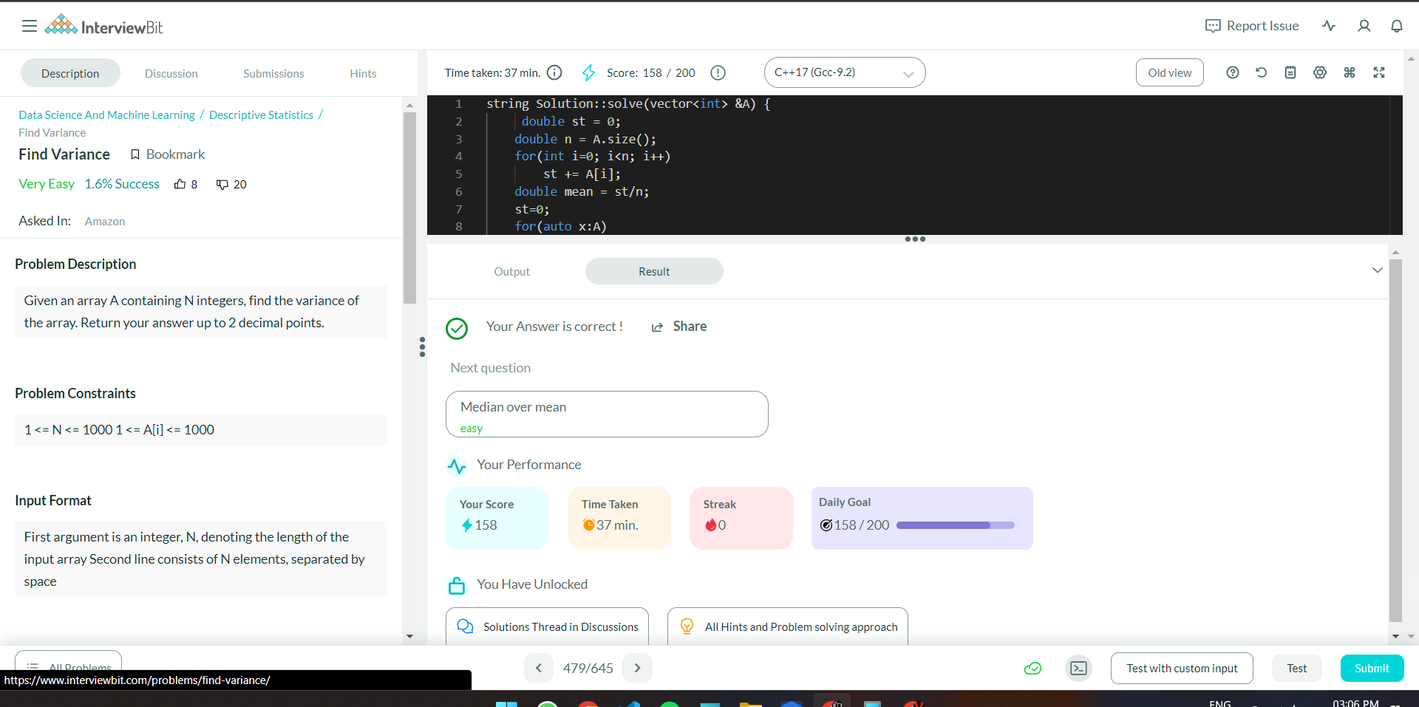

**Understanding about problem:**

* In this task there will be one vector and I need to return Variance value of array in string.

Note: If you can't understand the problem, feel free to contact us and we'll help you. Please don't copy and paste from anywhere.

ALL THE BEST

Team CP Club